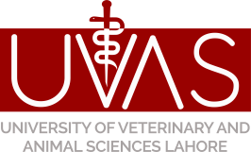
University of Veterinary and Animal Sciences, Lahore
Assessment/Evaluation of Old Material/ Dead Item Committee
Tel: +92-42-99213659, 99211449 (Ext: 292), Fax: +92-42-99211461, Cell # 0321 8402507, nadeem.ahmad@uvas.edu.pk

Performa for Unserviceable Items for Auction
Sr. # | Date of Purchase | Price at the time of Purchase (per unit) | Item with Complete Specification | Quantity | Estimated Price (By Department) |  | Approved price  (for Assessment Committee Use only)
 |  |  |  |  | Price Per Unit | Total Amount

01

02

03

04

05

06

07

08

09

10

Signature of HOD
Requesting Department/Institute

Assessment Committee

Mr. Amjad Mehmood Dr. Muhammad Asd Ali Assistant Director Internal Audit

(Convener) (Member) (Member)

Resident Auditor or his Representative Admin Office Purchase Cell Mr. Nadeem Ahmad

(Member) (Member) (Secretary/Member)

